Second blog post

Oof sorry for the long delay I was hoping to make a post sooner. I really did get swept away as soon as I got here. Now I’ve been in Singapore for nearly three weeks although it really only feels like a couple days.

I absolutely love it here. The city is incredible, there’s so much to do and explore it’s like nothing I’ve ever seen. The food is delicious and there’s so many interesting things to try. I could go on and on about this all day but I’m going to try to keep it short and just share a couple pictures from the trip so far.

This picture is from the gardens by the bay where they have these massive artificial trees. The trees are covered in lights that they show off in light shows every night.

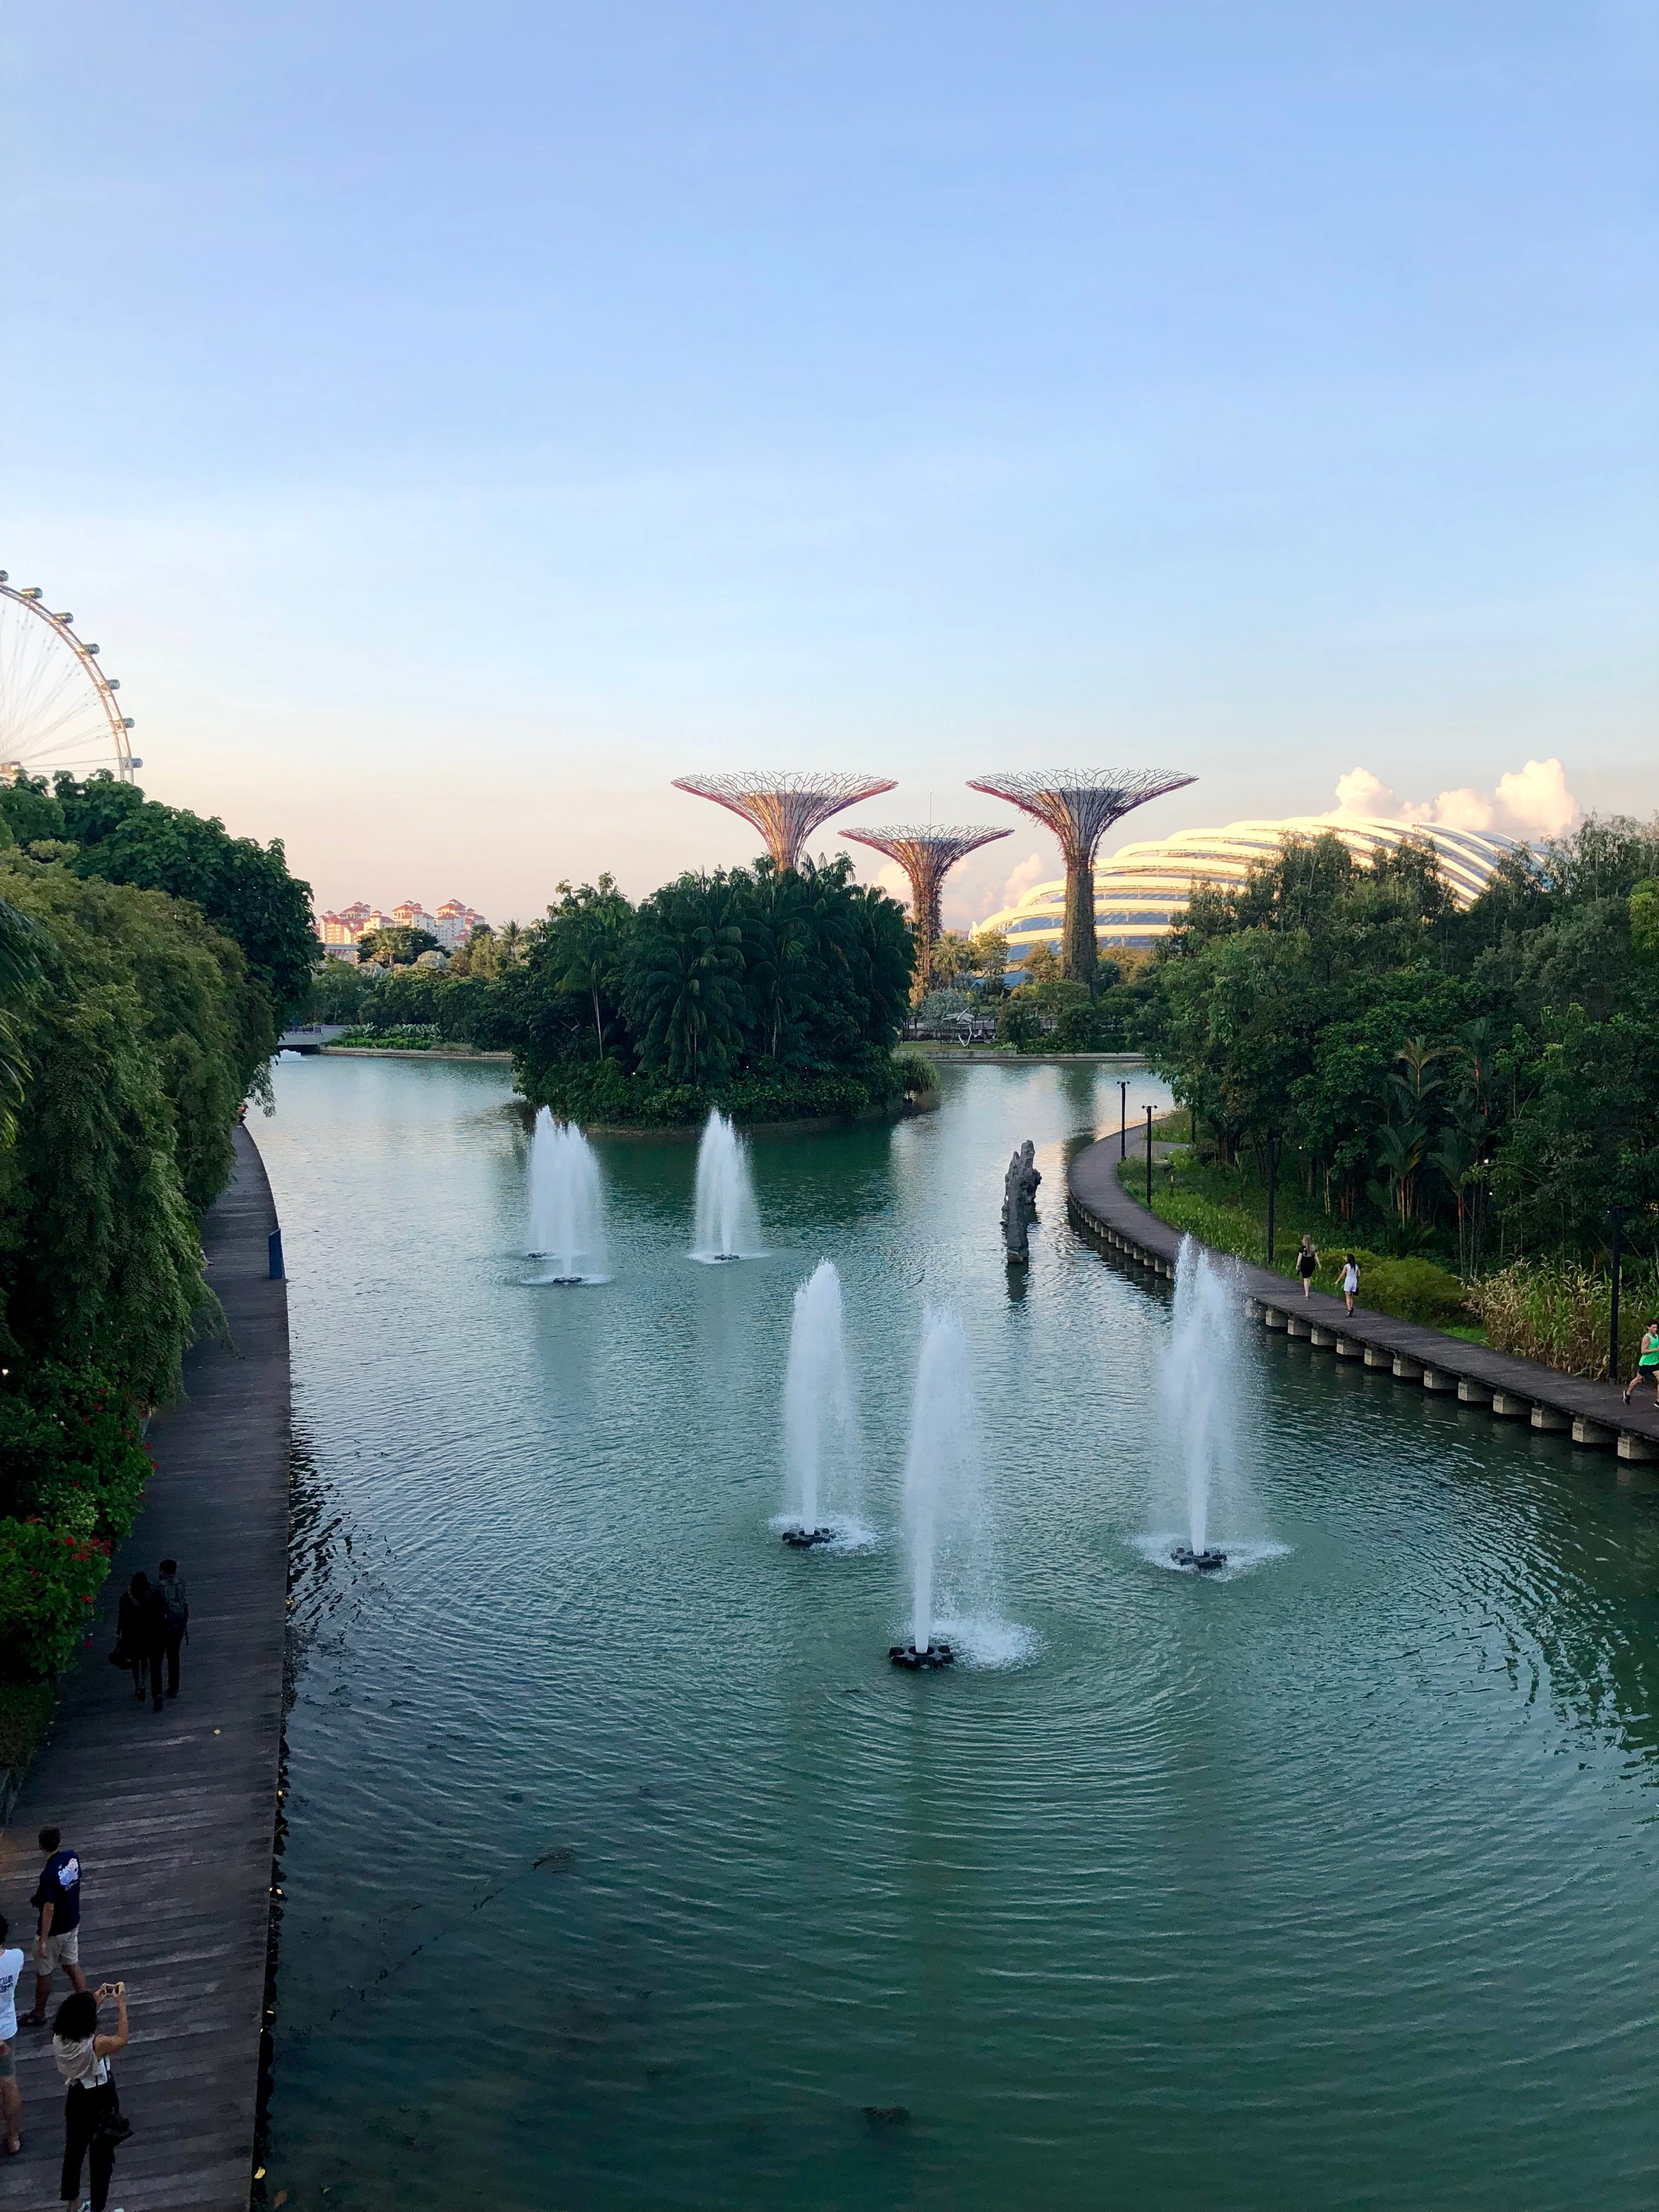

About a week ago we ended up in a Thai mall that was way outside of the normal tourist zones. It felt much more local than the other more touristy spots we have visited recently. The food we had there was amazing. Also, this was the first time I had seen Sharkfin Soup on the menu at a restaurant. We didn’t order it, but I thought the fact it was on the menu pretty interesting.

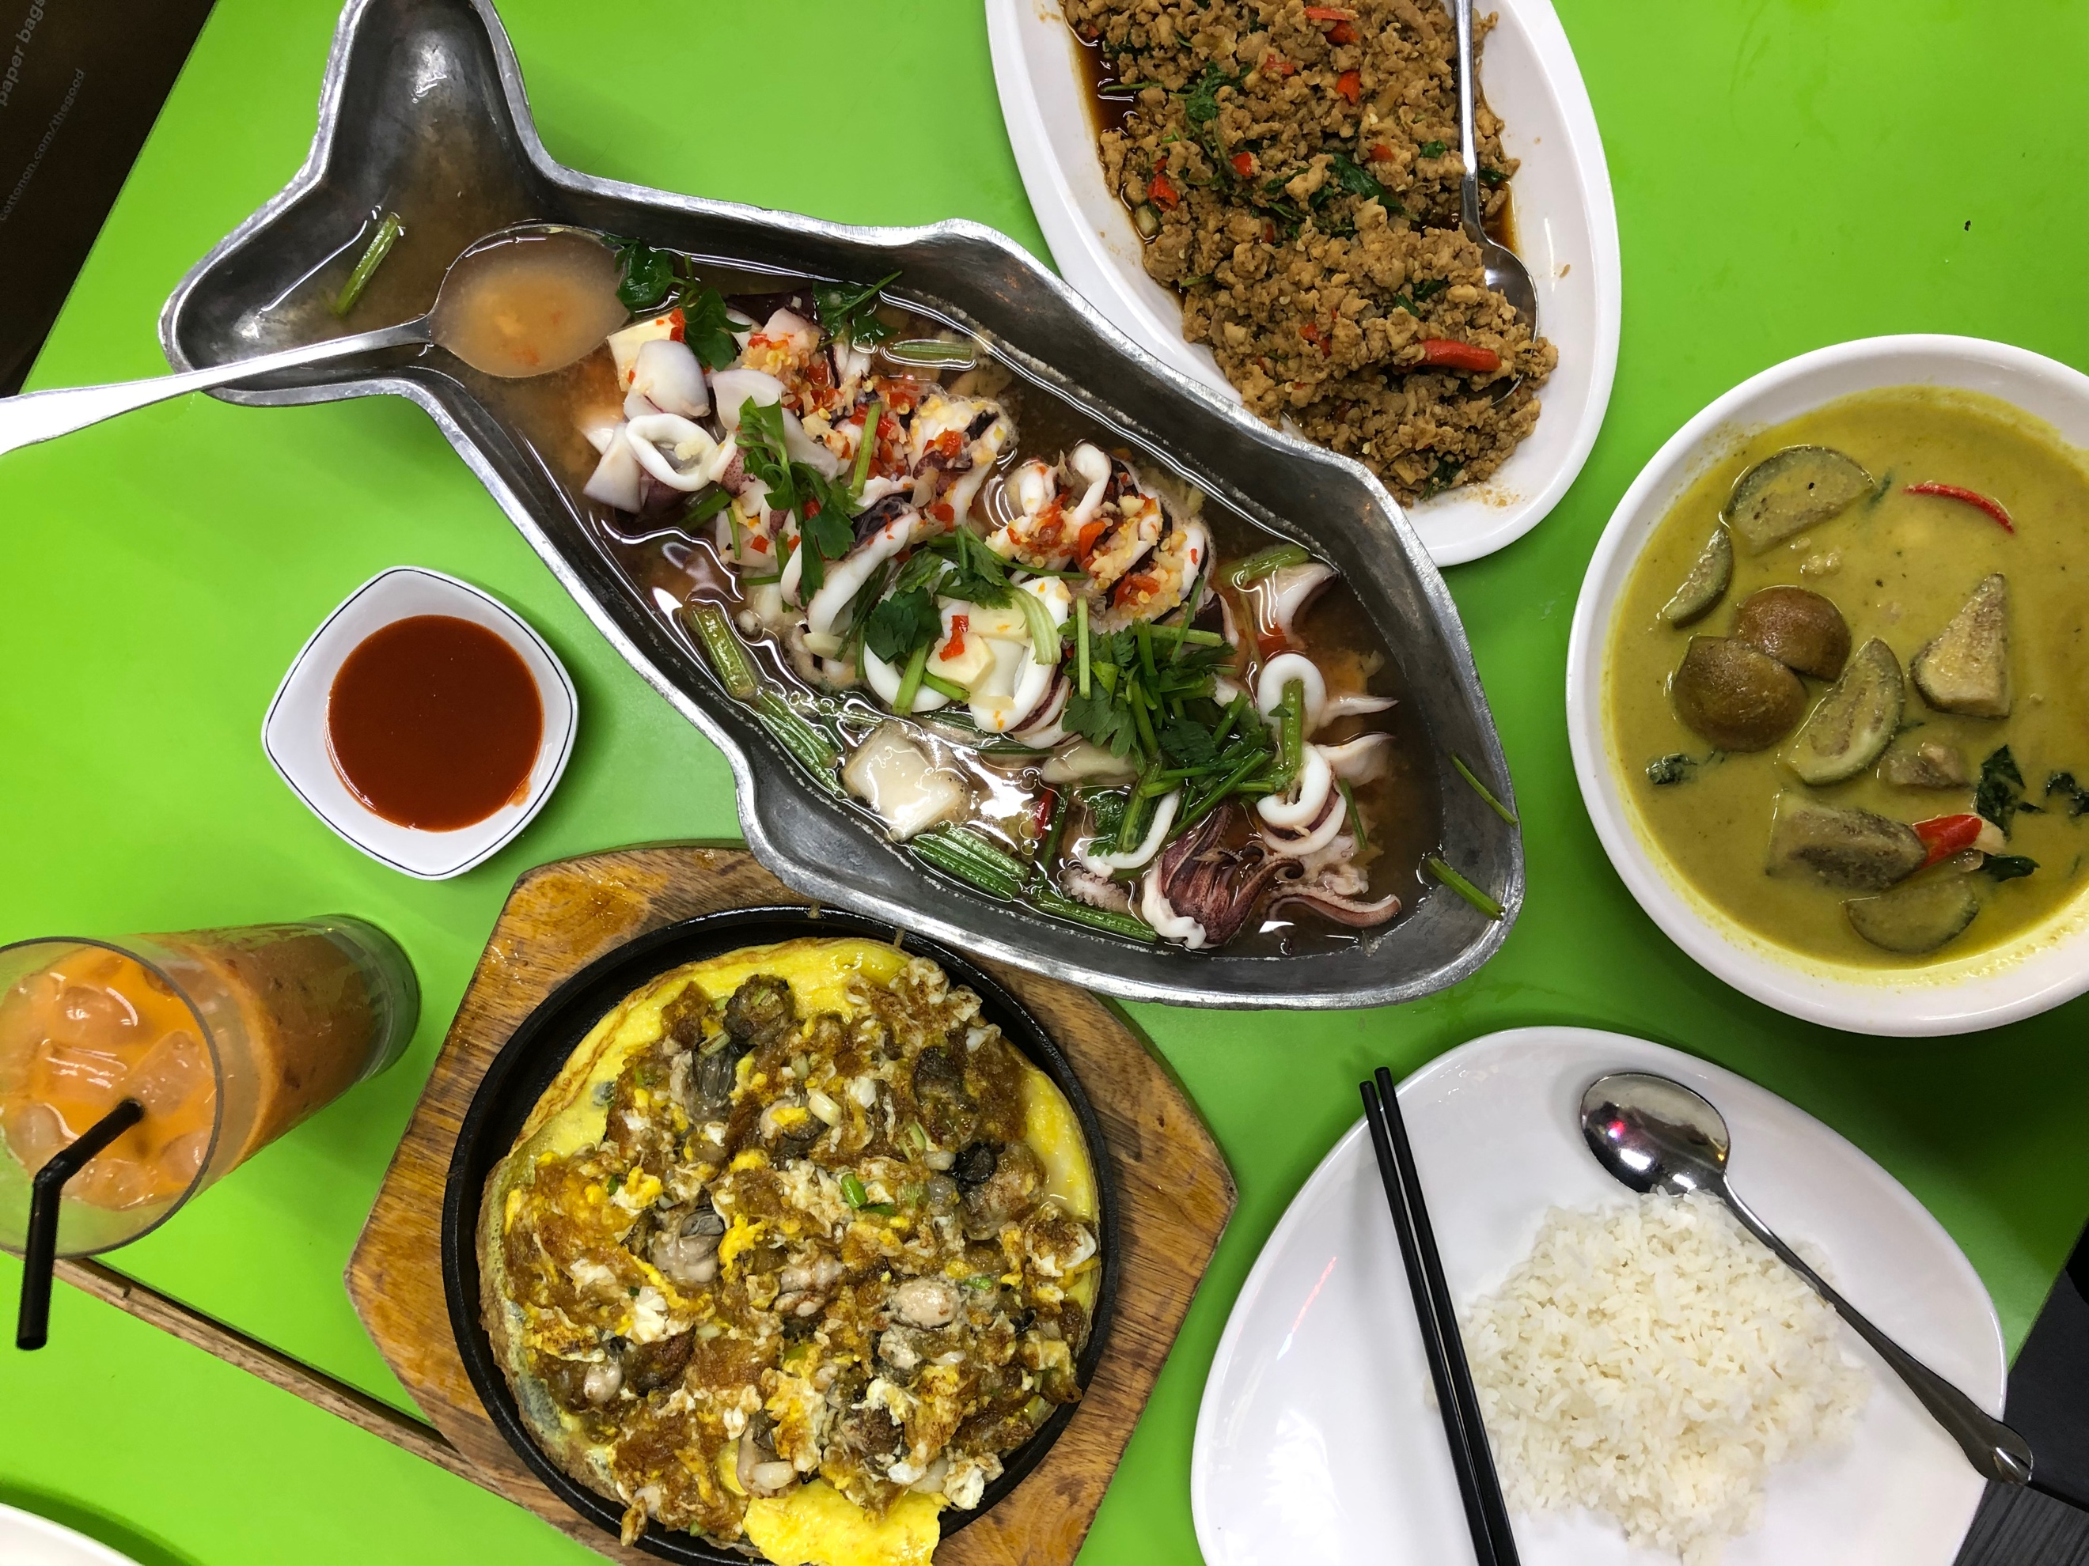

This is Marina Bay Sands the hotel that pretty much defines the Singapore skyline. It’s hard to explain but nearly everything here is done just a little bit over the top. This building really shows off that piece of their culture. It’s really expensive to stay here for a night but it gets you access to the infinity pool on the roof, so I’m tempted to get a room with some friends.

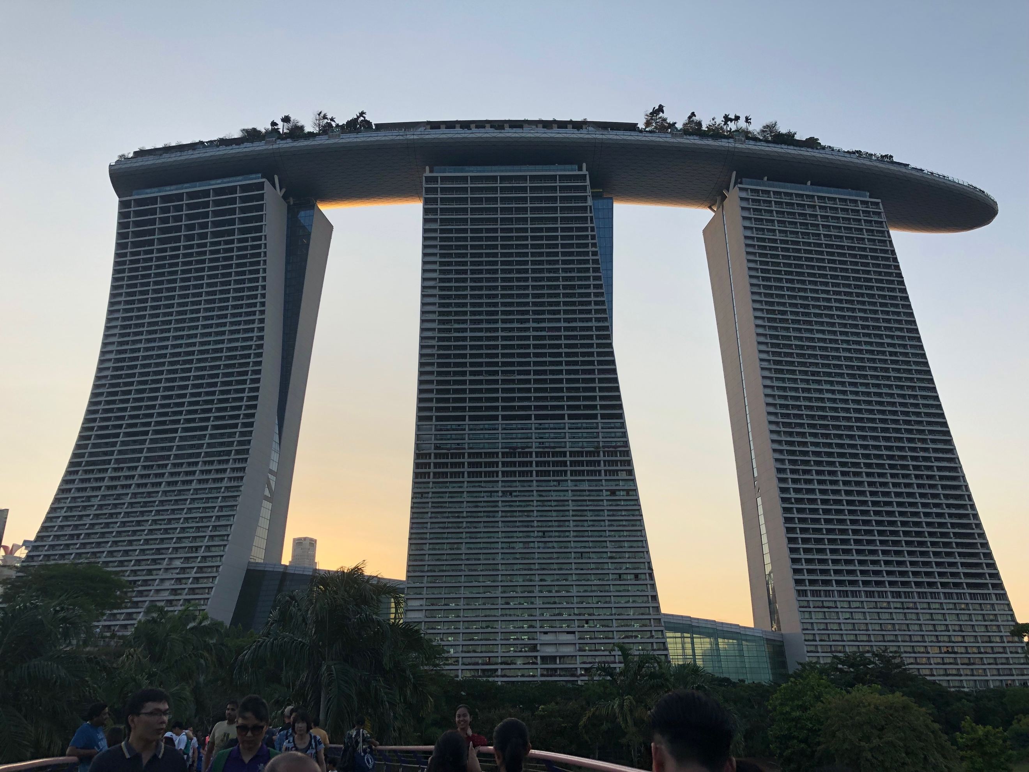

The botanic gardens in Singapore had an amazing bonsai garden with a bunch of different trees. I tried to get some really artsy pics with my phone camera

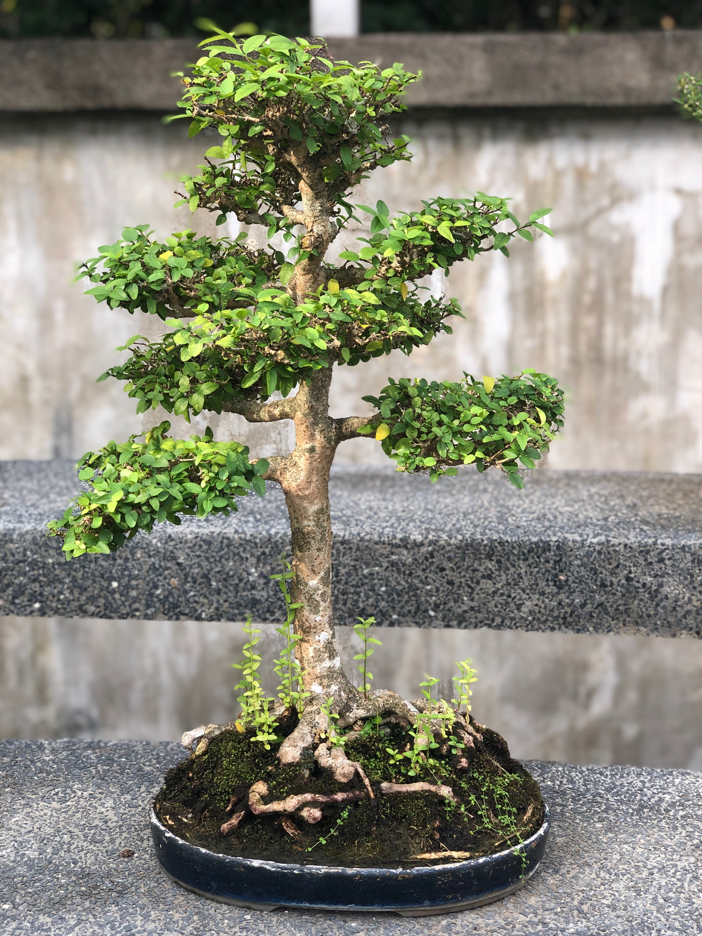

This last picture is our group that went to hang out at the beach the other day. From left to right:

John from New Jersey, yours truly from Colorado, Jurij from Russia/Germany, Nick from California, Natalia from Slovakia, Lorenz from Germany, Hendrik from Germany, Nate from Colorado, and Kevin from Colorado

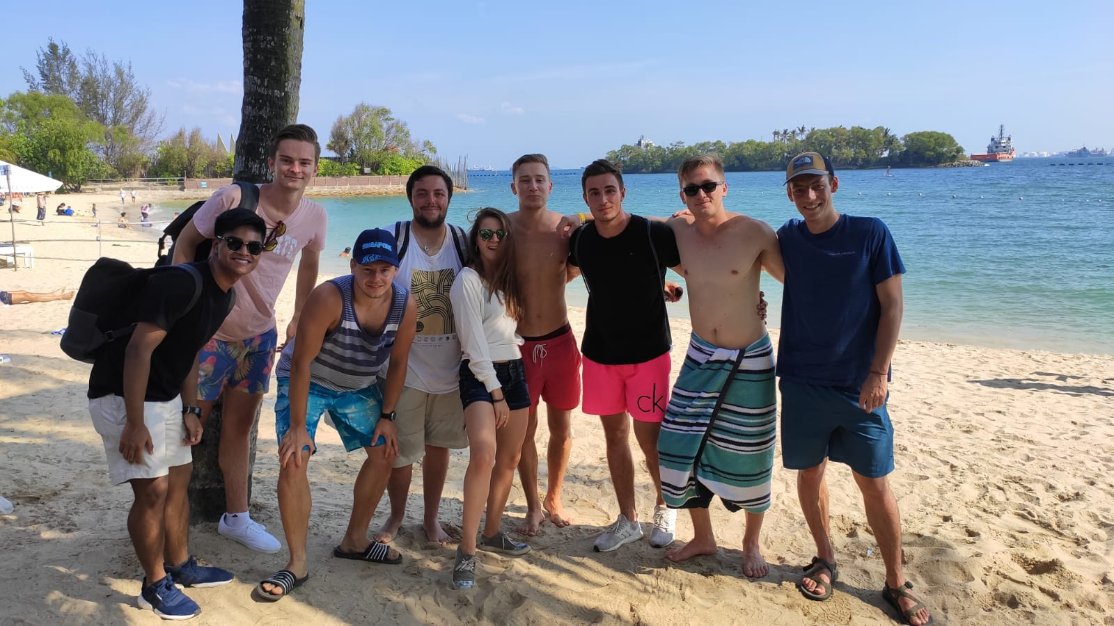

Singapore is incredible and I have lots more photos but I’ll end it here for now. On Thursday I’m leaving for Phuket, Thailand for my first international excursion. It’s the rainy season there so I’ve got my fingers crossed it doesn’t rain the whole time